Name__________________________ input.doc
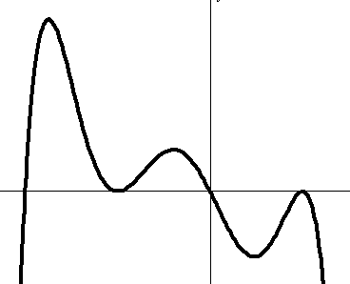
1) For the graph below: determine the degree, and if the coefficient of the highest term is positive or negative:

Degree ________

Positive or Negative ___________

2) Find a possible equation for the graph of the polynomial below.
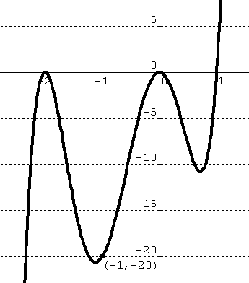

3) Sketch the following polynomials:
a) $f(x)=x^{2}(x−2)^{2}(x+2)$ b) $f(x)=3x^{3}−2x^{2}−5x$
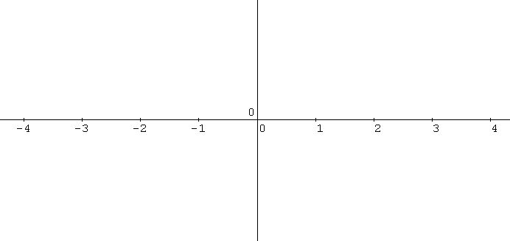

c) $f(x)=−2x^{4}+\text{18}x^{2}$ d) $f(x)=4x^{2}−\text{15}x−4$

